**Creating a webpage for viewing historical aerial imagery in Toronto**

Jeff Allen – January 2026

By looking at places from above, we can uncover the layered history of our communities and explore how they have changed over time.

I recently built a webpage for seamlessly viewing historical aerial imagery collected from various sources, to expedite historical exploration in Toronto (<https://schoolofcities.github.io/historical-aerial-imagery-toronto/>).

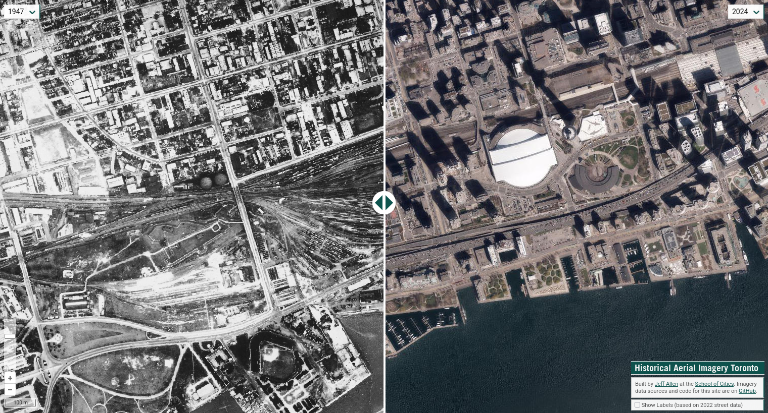

So why and how did I build this?

Organizations like the Map and Data Library (<https://mdl.library.utoronto.ca/air-photos>) and Toronto Archives (<https://www.toronto.ca/city-government/accountability-operations-customer-service/access-city-information-or-records/city-of-toronto-archives/whats-online/maps/aerial-photographs/> ) have a large digital collections of individual image files, which can be downloaded for different years and areas. The City of Toronto also has an interactive map which can be used to view a few years of historical imagery, alongside a swath of other data (<https://map.toronto.ca/torontomaps/>).

While these resources are great for sourcing data, they can be a bit cumbersome when seeking to quickly compare imagery at different locations and at different scales.

In mid-2022, I was doing some research on neighbourhood change in Toronto for which I was using aerial imagery to reference relative to other historical data. To help expedite historical exploratory analysis, I decided to build a tool that allows for panning around, zooming in/out, and selecting layers of imagery on a map of Toronto, , and which has a slider or swipe interaction for the quick comparison of multiple years.

(I have 1-2 .gif(s) to insert here – attaching to email separately)

Part of my inspiration was a similar tool that used to exist for Toronto’s historical imagery and photos, created by developers at Sidewalk Labs (<https://github.com/sidewalklabs/oldto>). But when Sidewalk Labs left Toronto in 2020, most of their web presence and links left the internet as well. I was disappointed by the loss of the webpage so I decided to create my own, using open source technology and imagery that was free and easily available.

I built my webpage using the web-mapping JavasScript library Open Layers (<https://openlayers.org/>). I specifically adapted an example (<https://openlayers.org/en/latest/examples/layer-swipe.html>) that swipes between two layers. Then I added a few buttons for selecting between years and zooming in-and-out on the map. The code for my project is hosted on GitHub (<https://github.com/schoolofcities/historical-aerial-imagery-toronto>) and served via GitHub pages (<https://docs.github.com/en/pages>).

When I initially built this project in 2022, I added imagery that the City of Toronto hosted as open data and is easily accessible via web map services (<https://open.toronto.ca/dataset/web-map-services/>). This included imagery for 1939, 1954, 1965, 1978, and from the 2000s. (Note that for 1939, I found that a big chunk of central Toronto was geo-referenced incorrectly, so for now I have ‘greyed’ it out.).

I soon wanted to start filling in some of the large gaps between years, to be able to view change over time at a more consistent rate. My goal was to have at least one set of imagery for every decade, so I started searching around for imagery from the 1940s, 1980s, and 1990s.

For the 1940s, the Map and Data Library had readily available (and open) imagery for 1947. One of our great research assistants, Doris (Yunhong) Tian, went through the source data and clipped the photos to remove their borders (this allows for seamless view across the region) and then geo-referenced them (so they could be overlaid and compared with imagery from other years based on their geographic location).

Here’s a view of the 1947 imagery centred on Queens Park and University of Toronto. Of particular interest to me here is how the street network has changed.

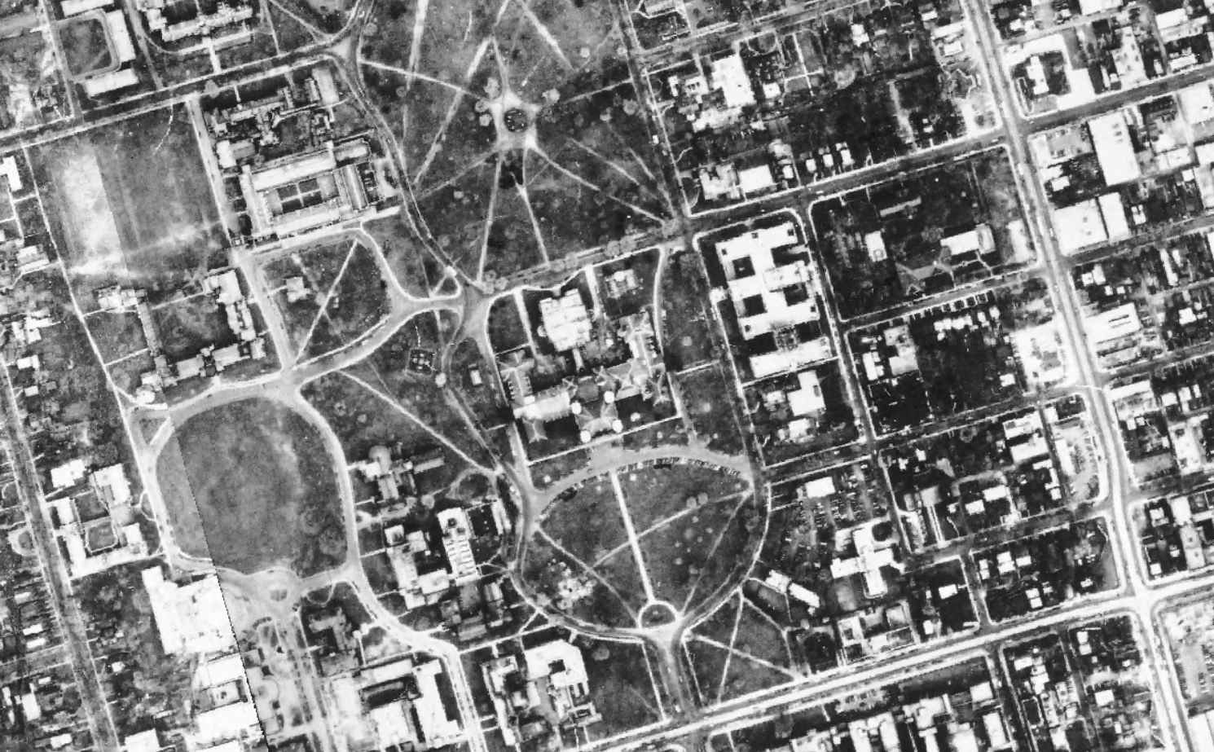

We used QGIS to convert the map into an XYZ raster tileset format ([https://docs.qgis.org/3.40/en/docs/user_manual/processing_algs/qgis/rastertools.html#generate-xyz-tiles-directory](https://docs.qgis.org/3.40/en/docs/user_manual/processing_algs/qgis/rastertools.html" \l "generate-xyz-tiles-directory)), which divides the large mosaic of imagery into a grid of small, manageable squares. These images are organized into a hierarchy based on their location (X and Y) and zoom level (Z), allowing the web map to load only the specific pieces needed as you move around.

For the 1980s, Toronto Archives holds multiple years of air photos, most of them held by copyright by private companies, who took the photos or currently hold their rights. Fortunately, we received permission for 1985 imagery, so we asked another great research assistant, Remus Herteg, to download, clip, geo-reference, and build an XYZ tileset similar to the one we did for 1947.

Here’s one view of the 1985 imagery that I find quite interesting – a big shadow being cast by the CN Tower over parking lots and industrial lands that have since been transformed into condos, offices, and other mixed-use urban development.

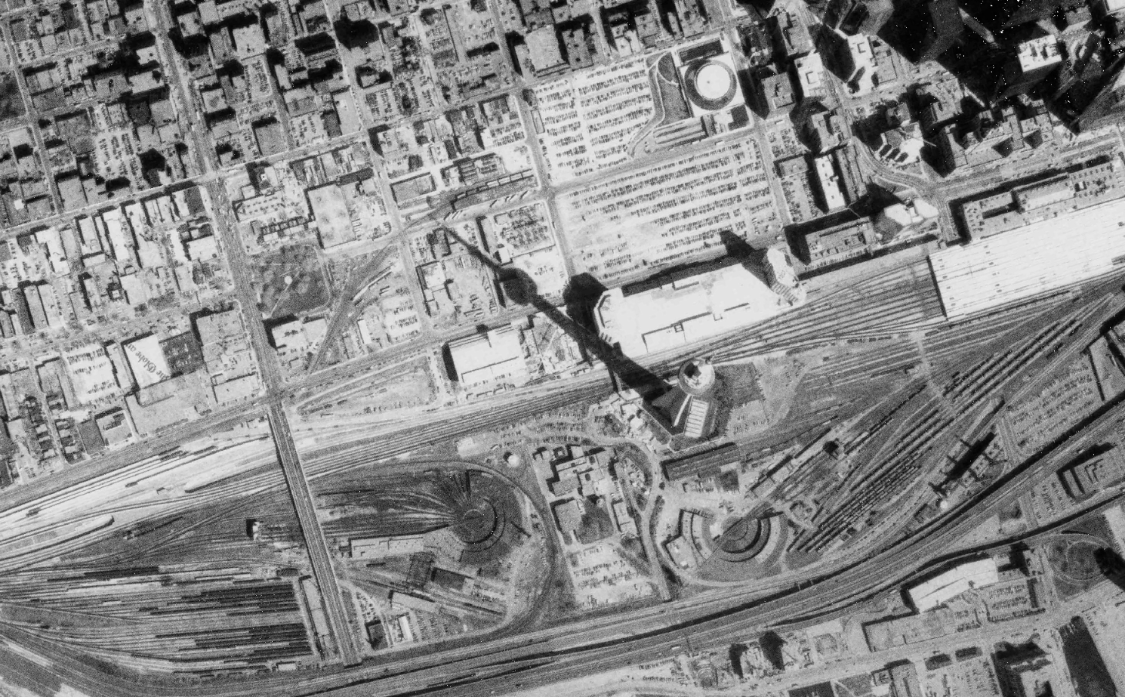

For the 1990s, the Map and Data Library had imagery available from 1995, which had recently become open data by the Ontario provincial government. This imagery was already clipped and georeferenced, so all I needed to do was create the XYZ tileset and have it hosted.

Here’s an example of this imagery in the east end – it shows the Greenwood Raceway shortly after it closed in 1993, but prior to it being redeveloped into housing, parking lots, and a large park.

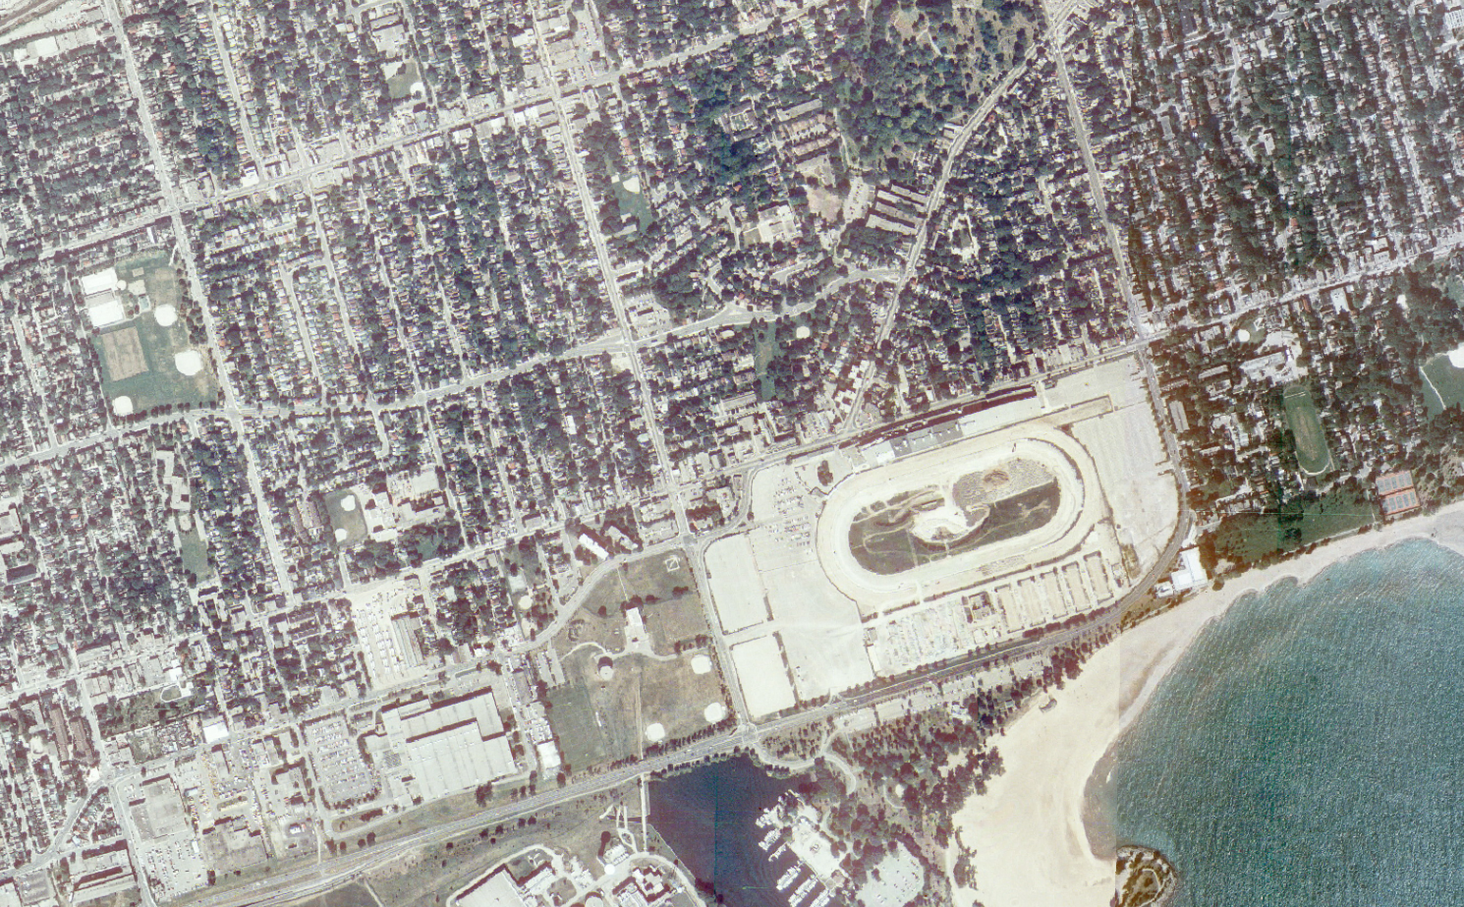

I’m happy with where this project is at now: there are no longer any big gaps between years, and we have every decade represented back to the 1930s. If I come across more imagery that is already clipped and georeferenced, I’ll try to add it to our webpage going forward. Please feel free to reach out if you have any questions about this project: [jeff.allen@utoronto.ca](mailto:jeff.allen@utoronto.ca)